USER ACCEPTANCE TEST

Pengadaan Perangkat Network Area dan Kantor Pusat 2026

Access Switch AREA BANDUNG ITB

Februari 17, 2026


PT. Berca Hardaya Perkasa (Bhp)
Authored by: Aditya Fauzi Ulfa

Contents

Contents 2
Revision History 3
Approvals 4
1. Document Purpose 5
2. Project Overview 5
3. Operation Guide 6
3.1 Device Management Acceptance 6
3.1.1 Port Status 6
3.1.2 Display of the Hardware Status 10
3.1.3 Power Supply Redundancy (If Available) 11
3.1.4 Interface Card 11
3.2 System Management Acceptance 12
3.2.1 Date & Time 12
3.2.2 LLDP 13
3.3 Administrative Configurations Acceptance 13
3.3.1 Hostname 13
3.3.2 Banner 14
3.3.3 Password 15
3.3.4 Interface Description 15
3.4 Terminal Service Acceptance 17
3.4.1 SSH Connection 17
3.5 Ethernet Function Acceptance 17
3.5.1 Link Type of an Interface 17
3.5.2 MAC Addresses 18
3.6 Switching Acceptance 19
3.6.1 VLAN 19
3.6.2 VLAN Trunking 19
3.6.3 InterVLAN Routing 20
3.7 Hardening Acceptance 21
3.7.1 Console port 21
3.7.2 Tacacs Integration 22
3.7.3 SSH Policy 23
3.7.4 SNMP Policy 23
3.7.5 Telnet Policy 24
3.7.6 Logging 25

Revision History
Version No. | Date | Revised by | Description of Change
1.0 | 17 Juli 2025 | Sanggra Marsha A | Initial Release

Approvals
Signature: |  | Date:
Name: | Sanggra Marsha A
Company: | PT. Berca Hardayaperkasa (BHp)
Role: | Network Engineer

Signature: |  | Date:
Name: | Deden
Company: | PT. Berca Hardayaperkasa (BHp)
Role: | Project Manager

Signature: |  | Date:
Name: | Bpk Alpin Kurniawan Syah Dongoran
Company: | PT. Bank Mandiri (Persero), Tbk
Role:

Signature: |  | Date:
Name: | Bpk. Husain Muhammad Makhluf
Company: | PT. Bank Mandiri (Persero), Tbk
Role:

Signature: |  | Date:
Name:
Company:
Role:

Signature: |  | Date:
Name:
Company:
Role:

Document Purpose
The purpose of this document is to describe the User Acceptance Testing (UAT) process for PENGADAAN PERANGKAT NETWORK IT AREA dan Kantor Pusat. Tests are performed to enable the user to validate that the device meets the agreed acceptance criteria.
.

Project Overview
This document is a User Acceptance Test (UAT) document for the “PENGADAAN PERANGKAT NETWORK IT AREA dan Kantor Pusat” project using Huawei. This document was created to verify and test the simulation results of the BHp planning and PT. Bank Mandiri (PERSERO), Tbk for implementation in the project mentioned above.

The User Acceptance Test (UAT) will be carried out based on test scenario that has been approved and agreed by Integra and PT. Bank Mandiri (PERSERO), Tbk. This UAT requires multiple tests with different roles depending on the testing type. Each test will be described in details with success or failure criteria in the expected result section, additional notes can be added in the notes section.

Operation Guide
  - Device Management Acceptance
    - Port Status
Objective | To make sure all port can light up.
Test Networking Diagram | 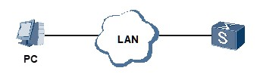
Prerequisites | - The switch has started.  - You have logged in to the switch from console or remotely.  - Undo shutdown all port
Procedure | Plugin cabling connected with client , and makesure status port up .
Expected Results | ACS-13020-01  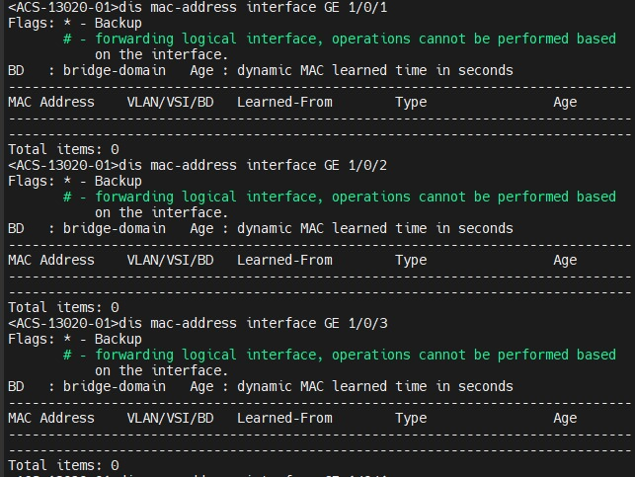  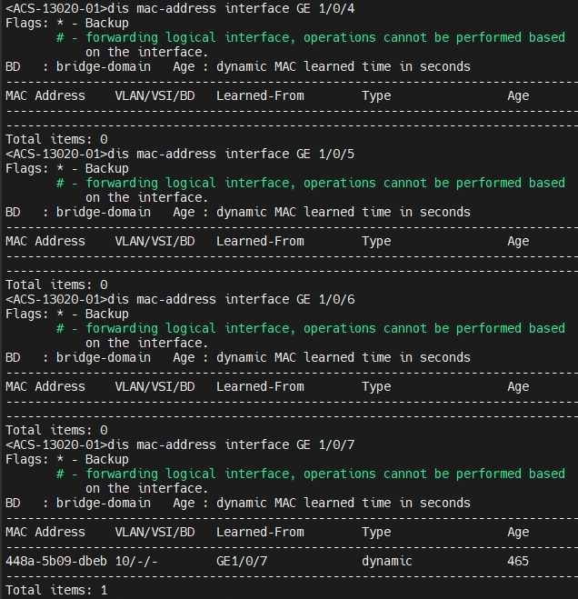  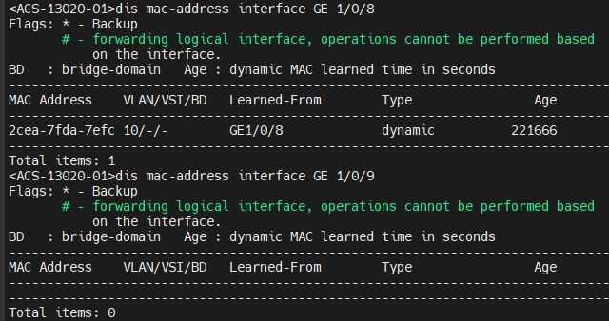  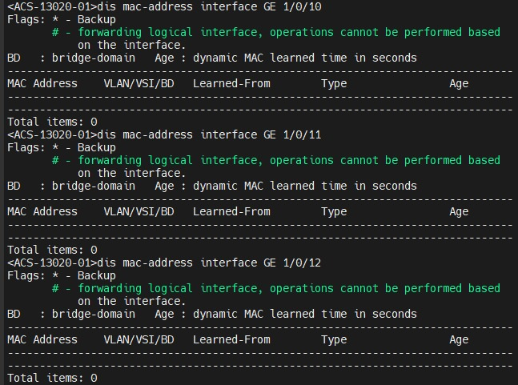  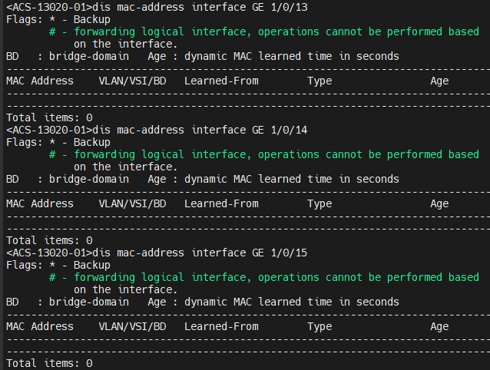  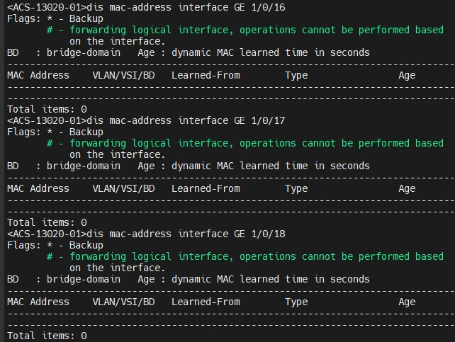  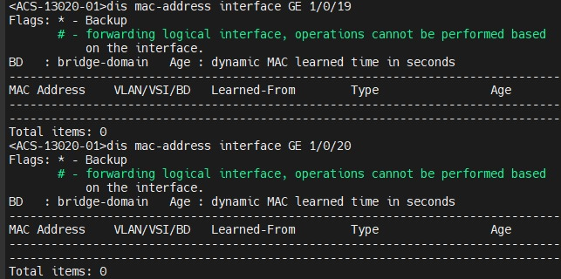  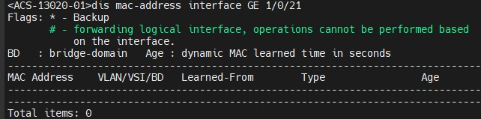  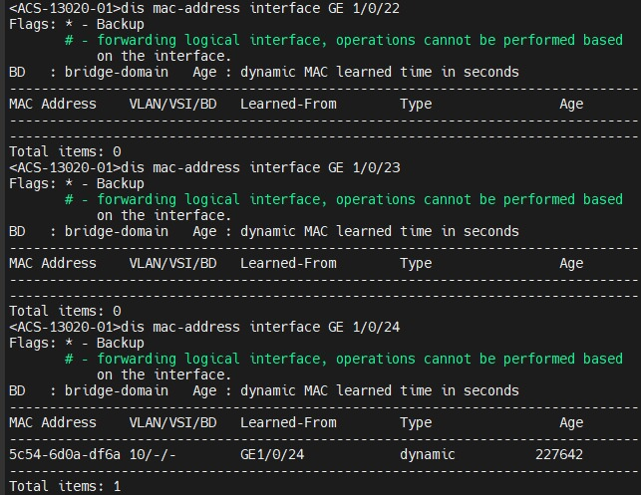
Test Description | All displayed parameters depend on the device status.

    - Display of the Hardware Status
Objective | To test the power supply redundancy function.
Test Networking Diagram | 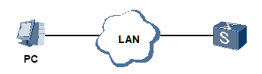
Prerequisites | - The switch has started.  - You have logged in to the switch from console or remotely.
Procedure | Run the display device command to check information about the system hardware.
Expected Results | ACS-13020-01  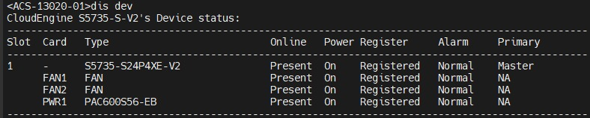
Test Description | Power cannot tested due to build-in PSU type

    - Power Supply Redundancy (If Available)
Objective | To test the power supply redundancy function.
Test Networking Diagram
Expected Results | ACS-13020-01  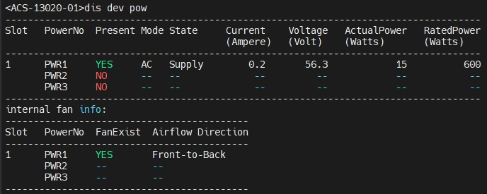
Prerequisites | - The switch is powered on.  2. You have logged in to the switch from console or remotely.
Procedure | - Install two PSUs on the switch and connect the power cables to the PSUs.  - Power on the switch and login using console or remote.  - Remove the power cable from one of the PSUs.
Test Description | Power cannot tested due to build-in PSU type

    - Interface Card
Objective | To test the interface card working properly.
Test Networking Diagram
Prerequisites | - The Switch to be tested starts normally.  - You have logged in to the Switch from a PC.
Procedure | Run the display elabel command in any view to view the electronic labels of the entities on the Switch.
Expected Results | ACS-13020-01  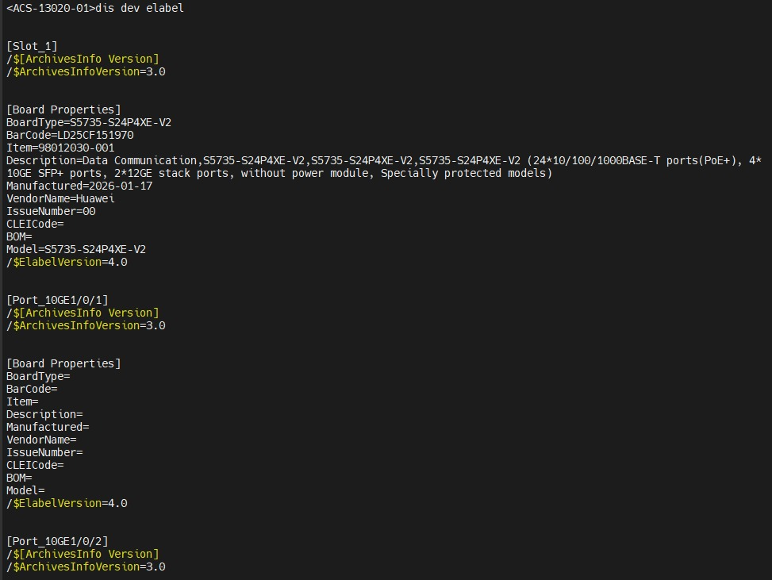
Test Description

  - System Management Acceptance
    - Date & Time
Objective | To test the date and time is correct.
Test Networking Diagram
Prerequisites | - The switch has started.  - You have logged in to the switch remotely from a PC.
Procedure | - Run the display ntp-service status command on the switch to view the ntp synchronize information  - Run the display clock command on the switch to view the system time.
Expected Results | ACS-13020-01  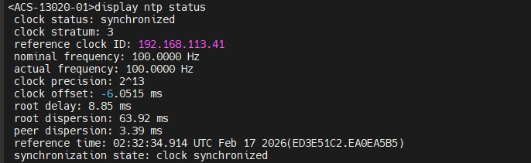
Test Description

    - LLDP
Objective | To test LLDP neighbor discovery
Test Networking Diagram
Prerequisites | - The Switch is the device to be test supporting LLDP.  - LLDP enabled in global configuration.
Procedure | Run the display lldp neighbor command on the switch to check the neighbor.
Expected Results | ACS-13020-01  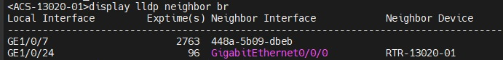
Test Description

  - Administrative Configurations Acceptance
    - Hostname
Objective | To test the Hostname is correct.
Test Networking Diagram
Prerequisites | Sysname configured in global configuration.
Procedure | Run the display current-configuration command on the switch to check the hostname.
Expected Results | ACS-13020-01  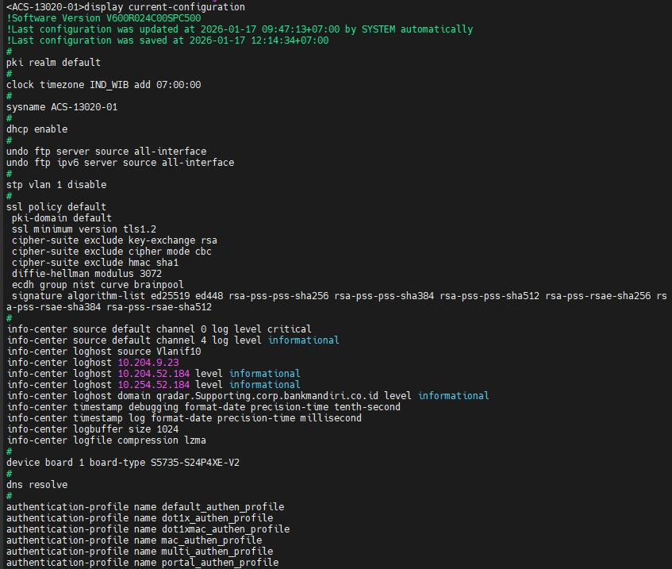
Test Description

    - Banner
Objective | To test the Banner is correct.
Test Networking Diagram
Prerequisites | - Header Login and Header Shell files are copied to the switch  - Banner is configured on the global configuration of the switch
Procedure | Login to the Switch by using console or terminal remote.
Expected Results | ACS-13020-01  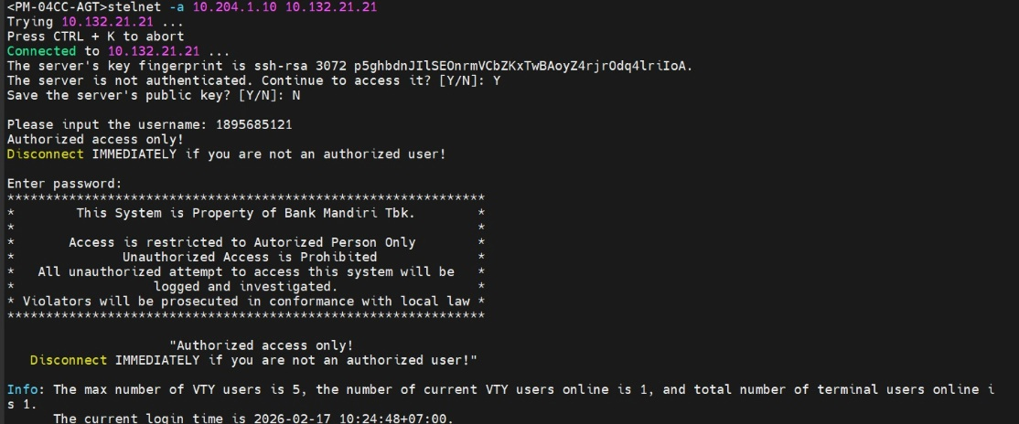
Test Description
    - Password
Objective | To test local username and password is already configured.
Test Networking Diagram
Prerequisites | - The switch has started.  - local username and password is already configured in aaa section.  - user-interface console and vty authentication using aaa.
Procedure | Logged in to the switch using ssh from a PC using local user Mandiri and password Mandiri123
Expected Results | ACS-13020-01
Test Description

    - Interface Description
Objective | To test the Interface Description is correct.
Test Networking Diagram
Prerequisites | - The switch has started.  - You have logged in to the switch remotely from a PC.  - Interface description has configured on the switch.
Procedure | Run the display interface description command on the switch to view all interface description.
Expected Results | ACS-13020-01  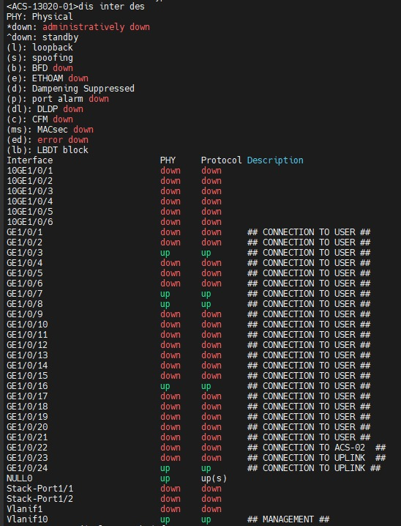
Test Description

  - Terminal Service Acceptance
    - SSH Connection
Objective | To test the SSH function.
Test Networking Diagram
Prerequisites | - The switch has started.  - The switch has registered to Tacacs server.  - The user-interface vty authentication using aaa.
Procedure | - Logged in to the AGT switch Plaza Mandiri  - From AGT switch, remote to target switch using ssh with credential from tacacs user.
Expected Results | ACS-13020-01
Test Description

  - Ethernet Function Acceptance
    - Link Type of an Interface
Objective | To check switching mode characteristics.
Test Networking Diagram
Prerequisites | - The switch has started.  - You have logged in to the switch remotely from a PC.
Procedure | Run the display stp instance 0 brief on the switch to view port role of stp.
Expected Results | ACS-13020-01  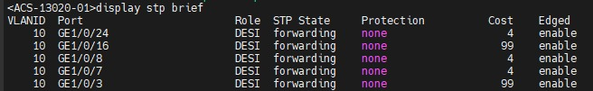
Test Description

    - MAC Addresses
Objective | To test switch can learn mac address from end-point that connected to the switch or from neighbor switch.
Test Networking Diagram
Prerequisites | - The switch has started.  - You have logged in to the switch remotely from a PC.
Procedure | Run the display mac-address command on the switch to view database of mac address learning.
Expected Results | ACS-13020-01  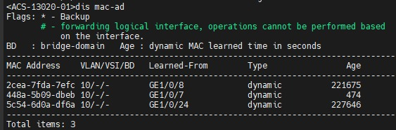
Test Description

  - Switching Acceptance
    - VLAN
Objective | To test vlan database already configured.
Test Networking Diagram
Prerequisites | - The switch has started.  - Vlan-id and vlan-name has configured
Procedure | Run the display vlan command to check the vlan database.
Expected Results | ACS-13020-01  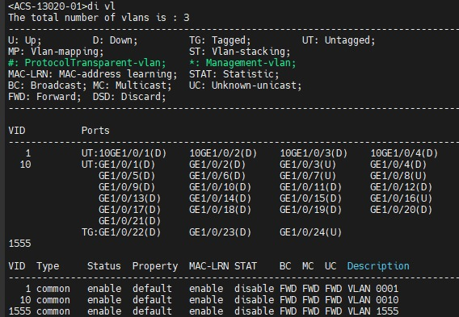
Test Description

    - VLAN Trunking
Objective | To test trunking port has configured on the switch
Test Networking Diagram
Prerequisites | - The switch has started.  2. Trunk interface has configured on uplink port witch specific vlan.
Procedure | Run the display port vlan command to check the port type (trunk/access)
Expected Results | ACS-13020-01  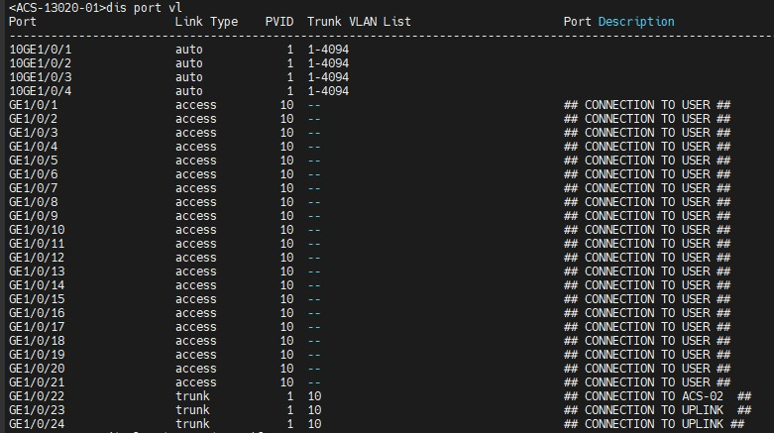
Test Description

    - InterVLAN Routing
Objective | To test the IP Management switch has routed to AGT switch
Test Networking Diagram
Prerequisites | - The switch has started.  - Default gateway has configured on the switch.
Procedure | Run the display ip routing-table command to check the routing table.
Expected Results | ACS-13020-01  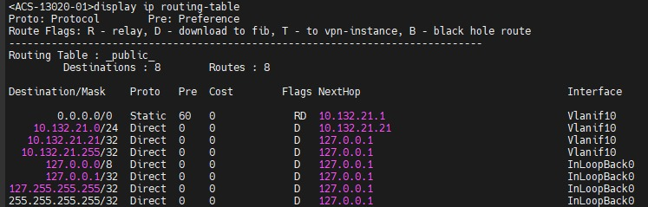
Test Description

  - Hardening Acceptance
    - Console port
Objective | To test login through console port with password authentication
Test Networking Diagram
Prerequisites | - The switch has started.  - User interface console has configured on the switch.
Procedure | - Use serial console cable.  - Login to the switch using tacact user.  - Run the display current-configuration configuration user-interface feature line command to verify console port config.
Expected Results | ACS-13020-01  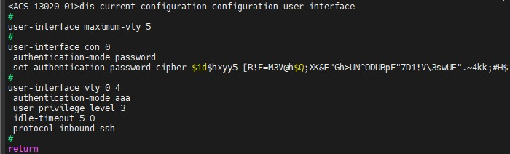
Test Description

    - Tacacs Integration
Objective | To test command-line authorization for users based on the HWTACACS Protocol
Test Networking Diagram
Prerequisites | - The switch has started.  - Tacacs profile has configured on the switch.
Procedure | Run the display hwtacacs-server template mandiri command to check switch has integrated to tacacs server.
Expected Results | ACS-13020-01  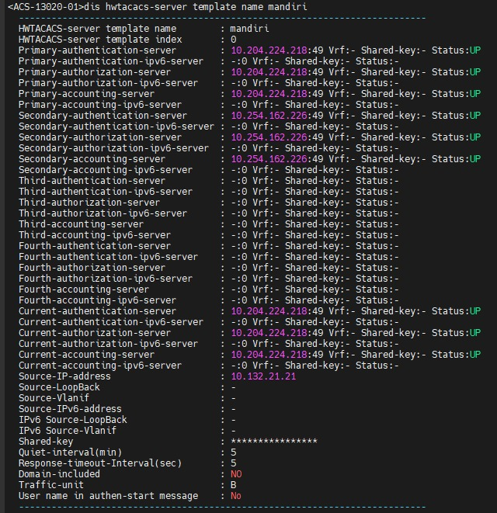
Test Description

    - SSH Policy
Objective | To test ACL on user interface vty working properly.
Test Networking Diagram
Prerequisites | - The switch has started.  - SSH has configured on the switch  - Access-list at user-interface has configured on the switch.
Procedure | - Login to Aggregator switch.  - Run the stelnet [ip address] command to test remote access switch.
Expected Results | ACS-13020-01  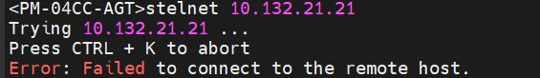

    - SNMP Policy
Objective | To check ACL on snmp-agent has configured.
Test Networking Diagram
Prerequisites | - The switch has started.  - ACL has applied on SNMP Agent configuration.
Procedure | - Run the display acl 2010 command to verify permitted source addresses.  - Run the display snmp-agent community command to verify ACL has added on snmp configuration.
Expected Results | ACS-13020-01  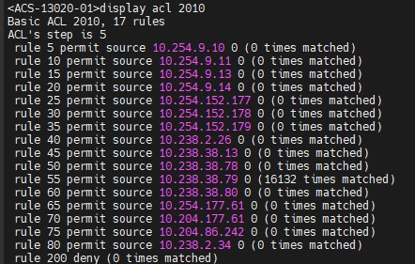  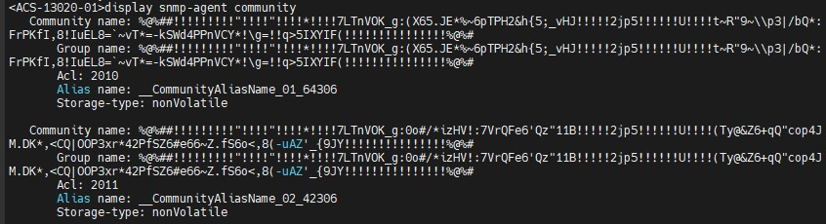

    - Telnet Policy
Objective | To test telnet service has disabled.
Test Networking Diagram
Prerequisites | - The switch has started.  - Telnet server configuration has disabled.
Procedure | - Login to AGT Switch on Plaza Mandiri.  - Run the telnet [ip address] command to test login to access switch.
Expected Results | ACS-13020-01  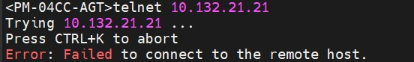
Test Description

    - Logging
Objective | To verify logging switch has configured properly.
Test Networking Diagram
Prerequisites | - The switch has started.  - Logging has configured.
Procedure | - Login to access switch.  - Run the display current-configuration filter info-center command to verify logging has configured properly.
Expected Results | ACS-13020-01  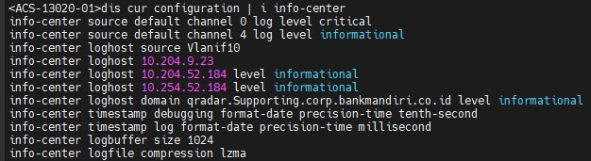
Test Description

